'Programmer: Samantha Naini
'Exercise: 3-3-74 pg.97 (***Revised***)
'Date: 2/20/2012
'Program purpose: Calculate the amount of a server's tip given the amount of the bill and the percentage tip obtained via input dialog boxes.

Option Strict On
Option Explicit On

Public Class frmServersTip

Private Sub btnCompute_Click(ByVal sender As System.Object, ByVal e As System.EventArgs) Handles btnCompute.Click
Dim Meal As Double = 0, percentageTip As Double = 0, amountOfTip As Double = 0

Meal = CDbl(InputBox("Enter cost of meal", "Cost of Meal"))

percentageTip = CDbl(InputBox("Enter percentage of tip", "Percentage Tip"))

amountOfTip = Meal * percentageTip / 100

txtResults.Text = "A " & FormatPercent(percentageTip / 100, 0) & " tip on " & FormatCurrency(Meal) & " is " & FormatCurrency(amountOfTip) & "."

End Sub

Private Sub btnClear_Click(ByVal sender As System.Object, ByVal e As System.EventArgs) Handles btnClear.Click
txtResults.Clear()
End Sub

Private Sub btnEnd_Click(ByVal sender As System.Object, ByVal e As System.EventArgs) Handles btnEnd.Click
Me.Close()
End Sub
End Class

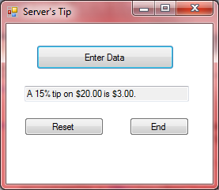

'Programmer: Samantha Naini
'Exercise: 3-3-75 pg.97
'Date: 2/23/2012
'Program purpose: Compute a balance over a ten-year period by entering in prinicpal and interest Rate.

Option Strict On
Option Explicit On

Public Class frmSavings

Dim Principal, Rate, Time, Result As Double

Private Sub btnCompute_Click(ByVal sender As System.Object, ByVal e As System.EventArgs) Handles btnCompute.Click
Principal = CDbl(txtPrincipal.Text)
Rate = CDbl(txtIntRate.Text)
Time = 10

Result = Principal * (1 + Rate) ^ Time
Result = Math.Round(Result, 2)

lstResults.Items.Add("When " & FormatCurrency(Principal) & " is")
lstResults.Items.Add("invested at " & FormatPercent(Rate) & "")
lstResults.Items.Add("for " & Time & " years, the")
lstResults.Items.Add("balance is " & FormatCurrency(Result) & ".")

End Sub

Private Sub btnClear_Click(ByVal sender As System.Object, ByVal e As System.EventArgs) Handles btnClear.Click
txtPrincipal.Clear()
txtIntRate.Clear()
txtPrincipal.Focus()
txtIntRate.Focus()

lstResults.Items.Clear()
End Sub

Private Sub btnEnd_Click(ByVal sender As System.Object, ByVal e As System.EventArgs) Handles btnEnd.Click

Dim prompt, title As String

prompt = "Have a great day!"
title = "Goodbye"

MessageBox.Show(prompt, title)
Me.Close()

End Sub

End Class
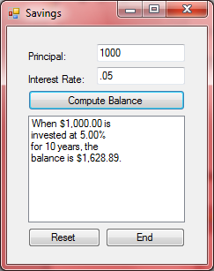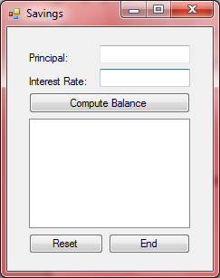⬅(clicking Reset)
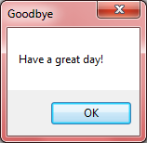⬅(pop-up when End button is clicked)

'Programmer: Samantha Naini
'Exercise: Programming Project 1, pg.100
'Date: 2/23/2012
'Program Purpose: Add, subtract, or multiply any two numbers entered by clicking on the corresponding buttons.

Option Strict On
Option Explicit On

Public Class frmCalculator

Private Sub btnAdd_Click(ByVal sender As System.Object, ByVal e As System.EventArgs) Handles btnAdd.Click
Dim Addition, a, b As Double

a = CDbl(txt1stNum.Text)
b = CDbl(txt2ndNum.Text)
Addition = a + b

txtResults.Text = "" & a & " + " & b & " = " & Addition & ""
txt1stNum.Clear()
txt2ndNum.Clear()
txt1stNum.Focus()

End Sub

Private Sub btnSubtract_Click(ByVal sender As System.Object, ByVal e As System.EventArgs) Handles btnSubtract.Click
Dim Subtraction, c, d As Double

c = CDbl(txt1stNum.Text)
d = CDbl(txt2ndNum.Text)
Subtraction = c - d

txtResults.Text = "" & c & " - " & d & " = " & Subtraction & ""
txt1stNum.Clear()
txt2ndNum.Clear()
txt1stNum.Focus()

End Sub

Private Sub btnMultiply_Click(ByVal sender As System.Object, ByVal e As System.EventArgs) Handles btnMultiply.Click

Dim Multiplication, f, g As Double

f = CDbl(txt1stNum.Text)
g = CDbl(txt2ndNum.Text)
Multiplication = f * g

txtResults.Text = "" & f & " x " & g & " = " & Multiplication & ""
txt1stNum.Clear()
txt2ndNum.Clear()
txt1stNum.Focus()

End Sub

Private Sub btnClear_Click(ByVal sender As System.Object, ByVal e As System.EventArgs) Handles btnClear.Click

txt1stNum.Clear()
txt2ndNum.Clear()
txt1stNum.Focus()
txtResults.Clear()

End Sub

Private Sub btnEnd_Click(ByVal sender As System.Object, ByVal e As System.EventArgs) Handles btnEnd.Click
Dim prompt, title As String

prompt = "Enjoy the rest of your day!"
title = "Bye bye"

MessageBox.Show(prompt, title)
Me.Close()

End Sub
End Class

Adding numbers: Subtracting numbers:
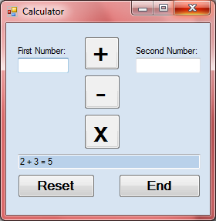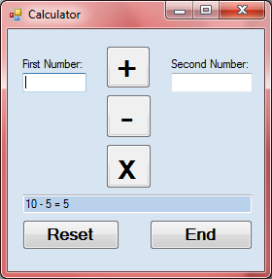

Multiplying numbers: End Prompt:
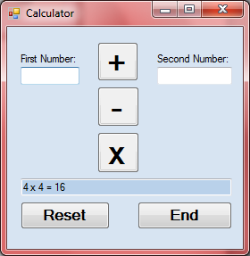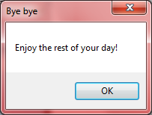

'Programmer: Samantha Naini
'Exercise: Programming Project 2, pg. 100
'Date: 2/23/2012
'Program Purpose: Display a simple auto repair bill showing the number of hours times 35 dollars, plus a 5% sales tax on supplies/parts cost.

Option Strict On
Option Explicit On

Public Class frmA1AutoRepair

Private Sub btnDisplay_Click(ByVal sender As System.Object, ByVal e As System.EventArgs) Handles btnDisplay.Click

Dim hourslabor, partssupplies, sum As Double
Dim customer As String

customer = CStr(txtCustomer.Text)

hourslabor = CDbl(txtLabor.Text) * 35
hourslabor = Math.Round(hourslabor, 2)

partssupplies = CDbl(txtSupplies.Text) * 1.05
partssupplies = Math.Round(partssupplies, 2)

sum = partssupplies + hourslabor
sum = Math.Round(sum, 2)

lstResults.Items.Add("Customer: " & customer & "")
lstResults.Items.Add("Labor cost: " & FormatCurrency(hourslabor) & "")
lstResults.Items.Add("Parts cost: " & FormatCurrency(partssupplies) & "")
lstResults.Items.Add("Total cost: " & FormatCurrency(sum) & "")

End Sub

Private Sub btnClear_Click(ByVal sender As System.Object, ByVal e As System.EventArgs) Handles btnClear.Click
txtCustomer.Clear()
txtCustomer.Focus()
txtLabor.Clear()
txtSupplies.Clear()
lstResults.Items.Clear()
End Sub

Private Sub btnEnd_Click(ByVal sender As System.Object, ByVal e As System.EventArgs) Handles btnEnd.Click
Dim prompt, title As String

prompt = "Have a great day!"
title = "Goodbye"

MessageBox.Show(prompt, title)
Me.Close()

End Sub

End Class
Ex1) Ex2)
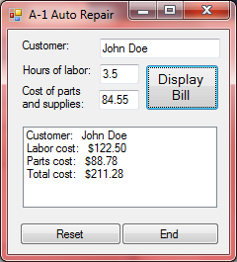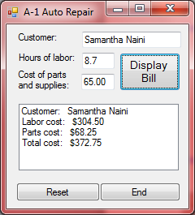
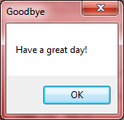←(pop-up for End button)

